**Earthquake Prediction Model using Python**

*AI_PHASES 2*

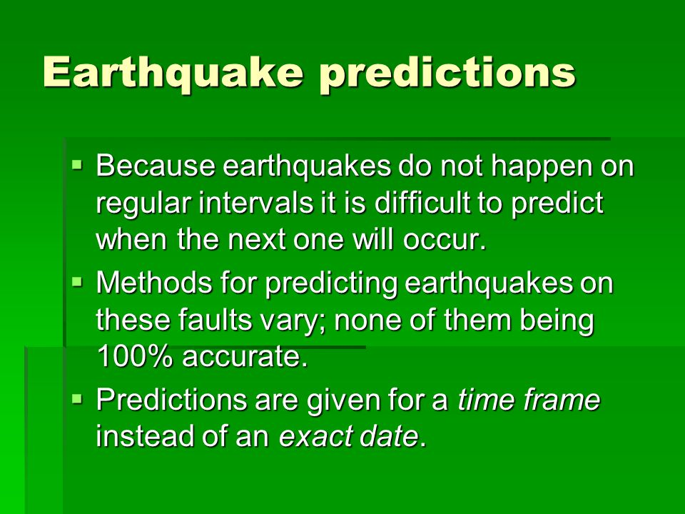

**Team Members:**

**Vijayavanan. J**

**III Year CSE**

**AI101 (IBM Artificial Intelligent Group 2)**

**Team Name: MiddleclassVIP Coder**

**Menter Name: Krisnaveni CSE HOD**

**SRG Engineering College, Namakkal**

***1.Data Collection:***

* Gather historical earthquake data from reliable sources like the US Geological Survey (USGS) or other earthquake monitoring agencies.

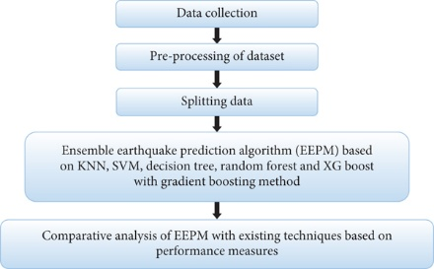

* Collect relevant features such as earthquake magnitude, depth, location (latitude and longitude), time, and any other relevant geological data.

***2. Data Preprocessing:***

* + Clean and preprocess the collected data. Handle missing values, outliers, and duplicate entries.
  + Convert geographical coordinates into meaningful features, such as distance from tectonic plate boundaries.

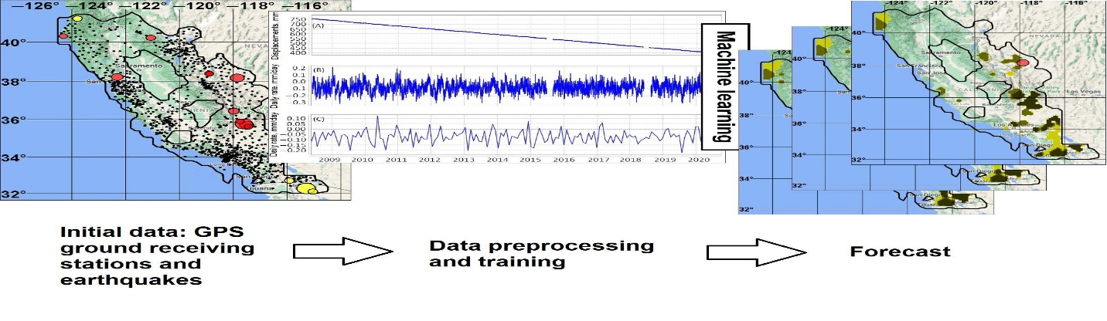

* Consider time series analysis techniques for handling time-related data.

***3. Feature Engineering:***

* + Create new features that might be relevant to earthquake prediction, such as seismic activity trends over time, proximity to fault lines, etc.
  + Normalize or standardize features as needed.

***4. Model Selection:***

* + Experiment with different machine learning algorithms like Random Forest, Gradient Boosting, or Deep Learning architectures (e.g., Neural Networks).
  + Explore ensemble methods (e.g., stacking) to combine the strengths of multiple models.

***5. Hyperparameter Tuning:***

* + Use techniques like grid search or random search to find the best hyperparameters for your chosen models.

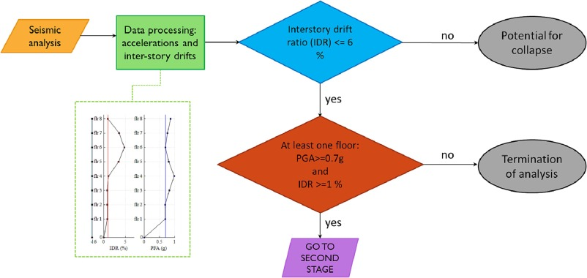

* + Consider libraries like scikit-learn and TensorFlow/Keras for hyperparameter tuning.

***6. Model Training and Evaluation:***

* + Split your dataset into training, validation, and test sets.
  + Train your models on the training data and evaluate their performance on the validation set.
  + Use appropriate evaluation metrics for regression tasks (e.g., Mean Absolute Error, Root Mean Squared Error).

***7. Model Validation:***

* + Perform cross-validation to ensure the robustness of your models.
  + Address overfitting issues if they arise.

***8. Model Deployment:***

* + Once satisfied with the model's performance, deploy it in a real-time or batch prediction environment.
  + Create a user-friendly interface for end-users to access predictions.

***9. Continuous Monitoring and Updating:***

* + Earthquake prediction models may need constant updates as new data becomes available.

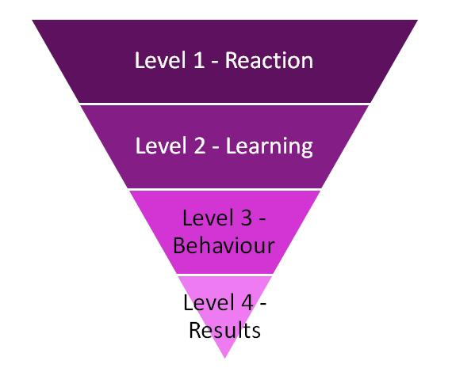

* + Implement a system to retrain and update your model periodically.

***10. Documentation and Reporting:***

* + Document your entire project, including data sources, preprocessing steps, model architectures, and results.
  + Create a detailed report summarizing your findings and the performance of your earthquake prediction model.

***11. Ethical Considerations:***

* + Ensure that your model does not produce biased or discriminatory results.
  + Consider the ethical implications of earthquake prediction, especially if it leads to evacuation or other safety measures.

***12. Collaboration and Peer Review:***

* + Collaborate with domain experts in geology and seismology for valuable insights.

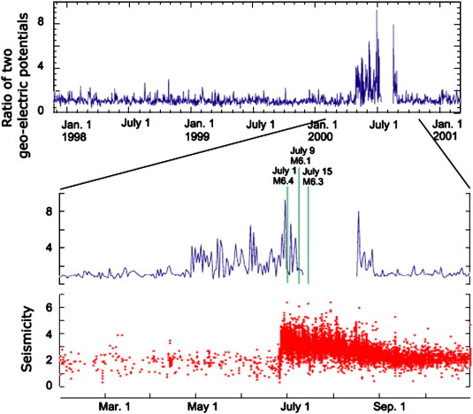

* + Seek peer review to validate your methodology and findings.

This is a high-level overview, and each step can be quite involved. Earthquake prediction is a challenging task, and there are no guarantees of high accuracy due to the complexity of natural phenomena. Keep in mind that your model's performance will heavily depend on the quality and quantity of the data you can access.